Long Term Overview: The Reading Journey for Year 3 2021-2022 Non-Fiction Fiction Poetry Author focus
Autumn 1 | Autumn 2 | Spring 1 | Spring 2 | Summer 1 | Summer 2
Reading Journey | Reading Journey | Reading Journey | Reading Journey | Reading Journey | Reading Journey
Gods & Mortals  Narrative – Theseus & the Minotaur  Narrative-VIPERS  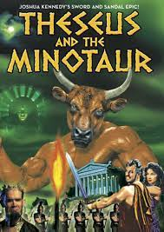  Non-Fiction:  #  Poetry (National Poetry Day Acrostic Poems)  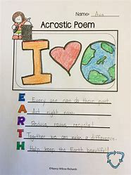  Multi-faith week: Hinduism  Rama & Sita  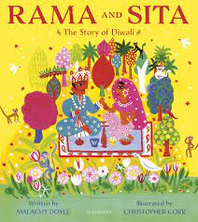 | The Hodgeheg  Narrative:  The Hodgeheg  VIPERS  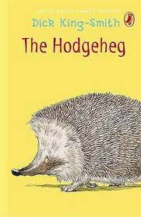  Poetry: | Tribal Tales  Narrative:  The Hodgeheg  VIPERS  Narrative – The Woolly Mammoth  VIPERS  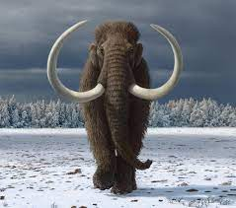  Poetry: | Flow  Non-fiction:  Why Water’s  Worth It.  VIPERS  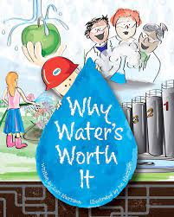  Poetry: | Rocks, Relics & Rumbles  Narrative: Escape From Pompeii  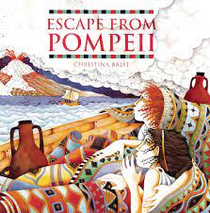  Poetry: | Scrumdiddlyumptious  Poetry:

